**Deliverable task-**

* Create a virtual network with 2 subnets. Each subnet should have 16 Ips only.
* Inside one of the subnets, create a VM and deploy an application code inside it and it should leverage the database on the cloud (any existing application created by you before)
* Deploy the same application to Azure App Service. It should also leverage the database on the cloud.
* Create the AKS cluster (2 nodes, smallest size VM) and deploy any two services on it. Services should be accessible from the internet.
* Create an Azure function that should trigger as soon as you upload a file in the blob storage. Function should be able to print the name of the file uploaded in the function.

1 Create a virtual network with 2 subnets. Each subnet should have 16 Ips only.

Create virtual network with 16 lps

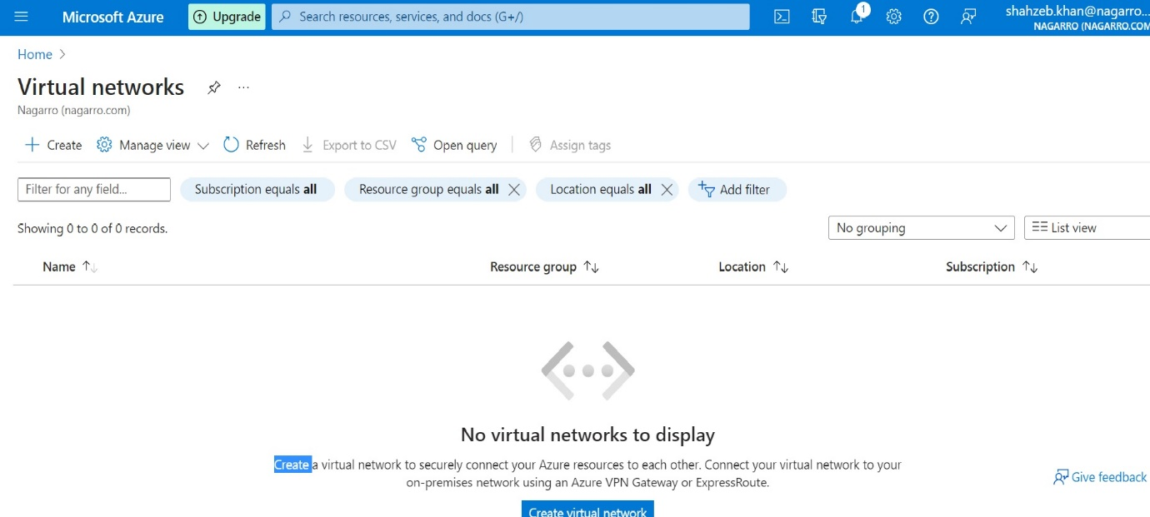

Create a basic virtual network of two subnet name khan-VN with 16 lps then press the create button after giving information about virtual network .

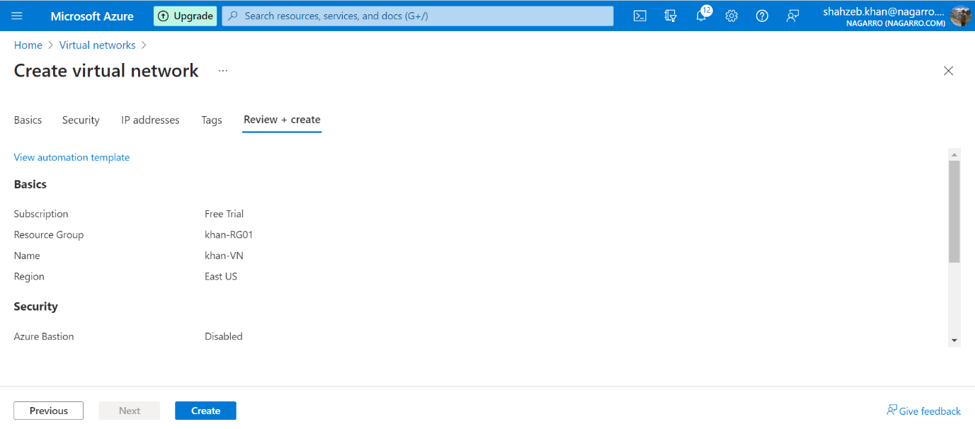

Successfully create virtual network with two subnet

2. Inside one of the subnets, create a VM and deploy an application code inside it and it should leverage the database on the cloud

First create a Virtual machine name vm-shah in a subnet vnet-shah

Successfully create a Virtual Machine

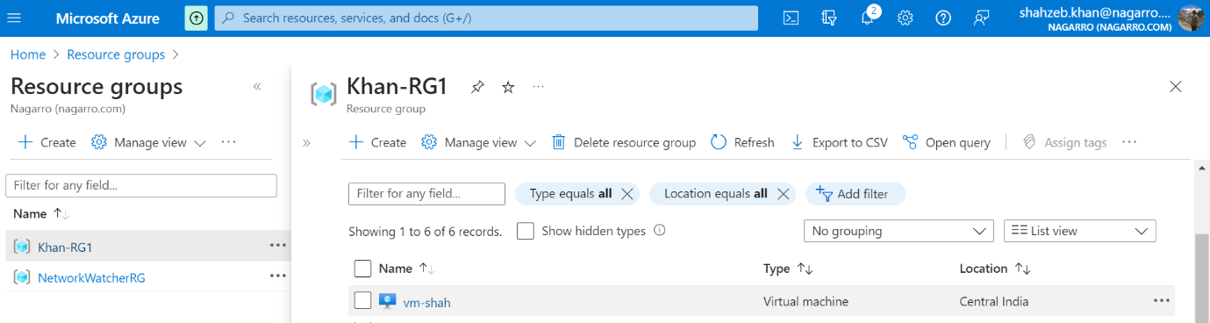

Then create database SQL in azure of name dB-shah and server-shah as server name.

Successfully created database.

Then go to overview of database and copy the connection string from jdbc and paste in spring boot application.YML. Then run an application again.

Then connect the VM through RDP

Then enter password for login in VM

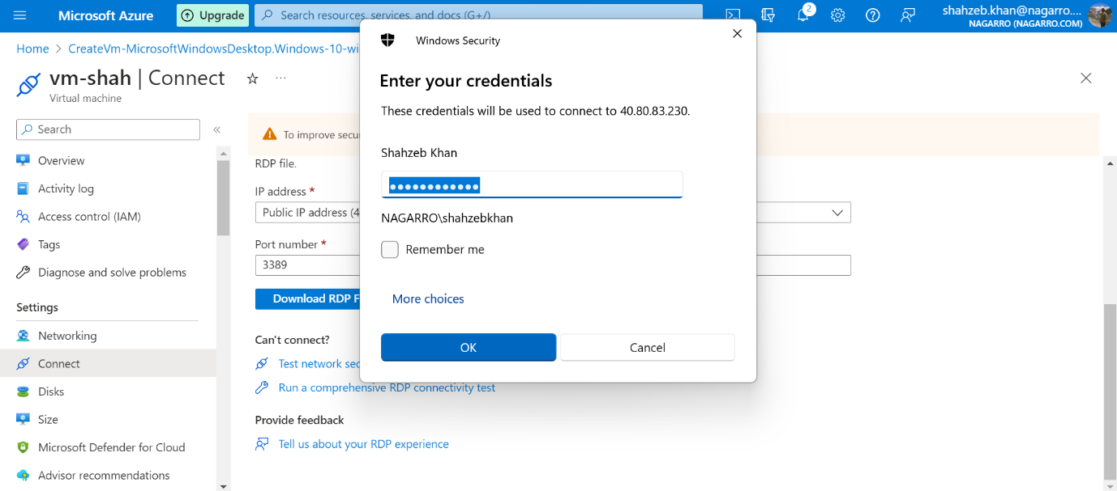

Then it is successfully login in Virtual machine

This is the configure file for database connection in azure of application running in Virtual machine .

Then run the spring boot application in Virtual machine in VS Code Editor.

Then hit the Add employee API in POSTMAN then one entry id added in database of azure.

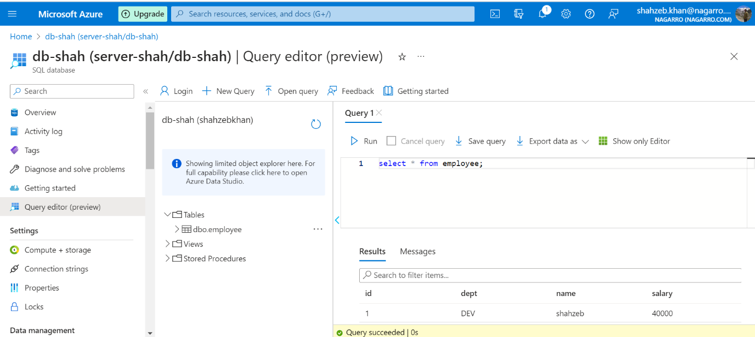

Then Hit get API of employee which fetch all information of employees.

3. Deploy the same application to Azure App Service. It should also leverage the database on the cloud.

Create SQL Database

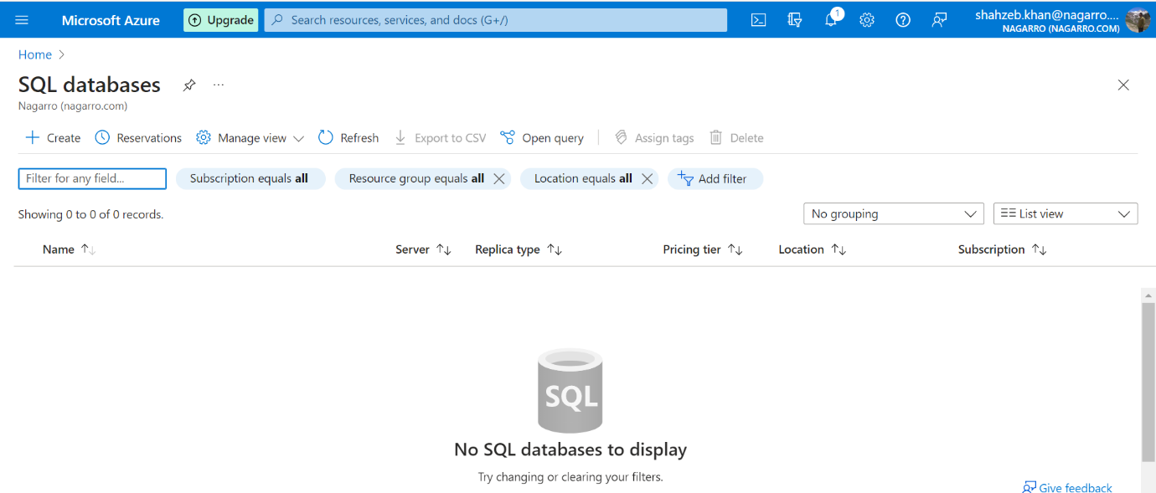

Create SQL Database with database name crud-dB and server name crud-server1.

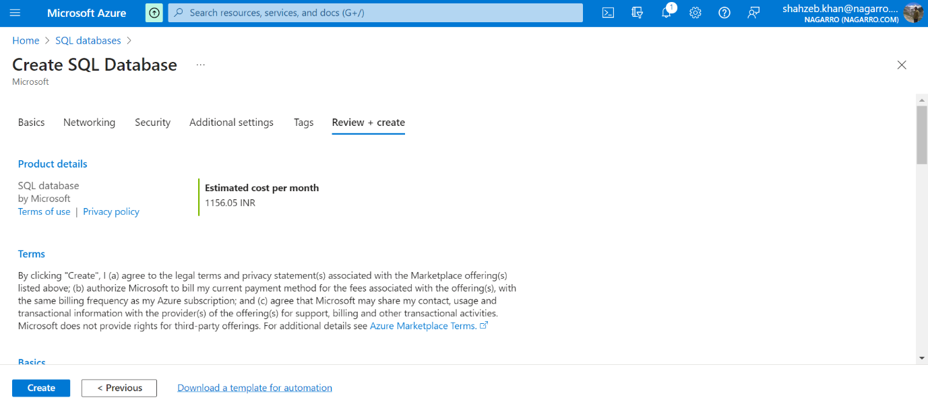

Successfully created SQL Database and SQL Server

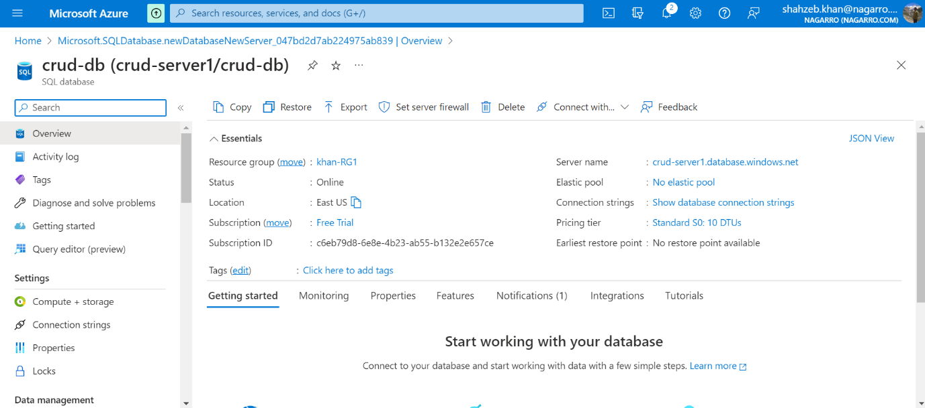

Then copy the connection string and paste it in the property file in URL. Then start the application again and hit the API.

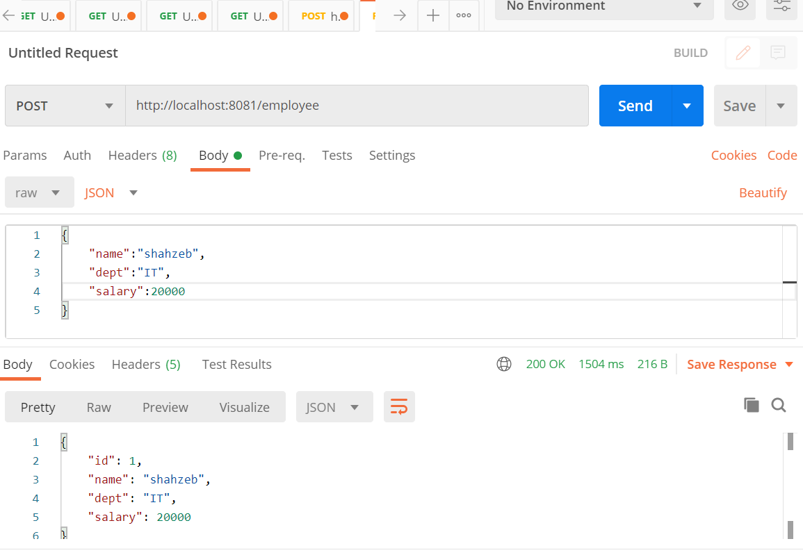

Employee information added in azure database.

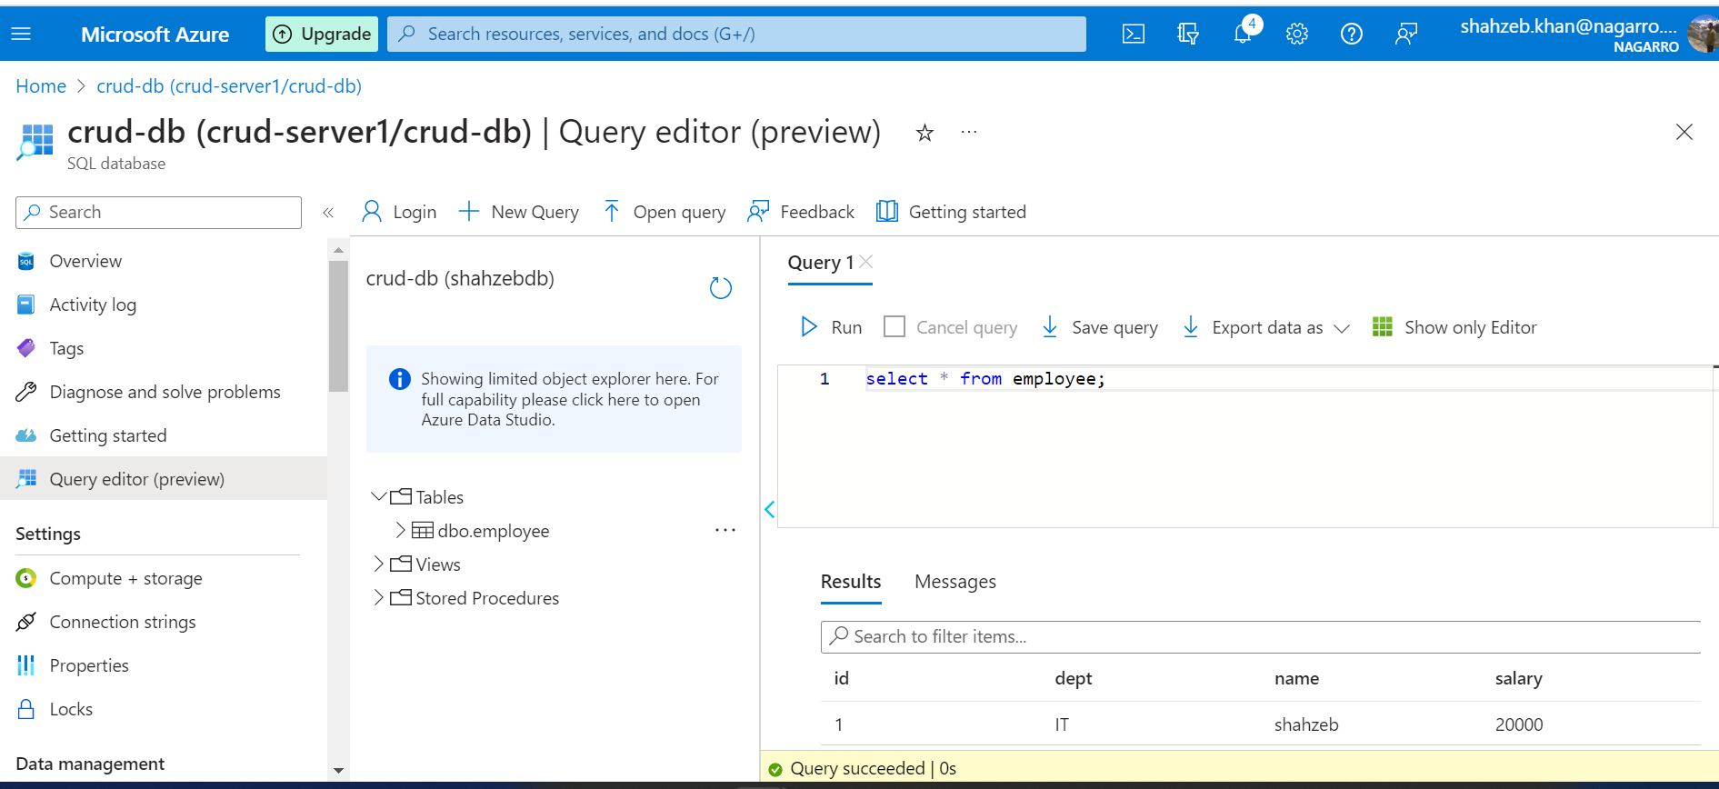

Then Upload the spring boot project in GitHub then create Web APP of name crud-application and pull the code from GitHub .

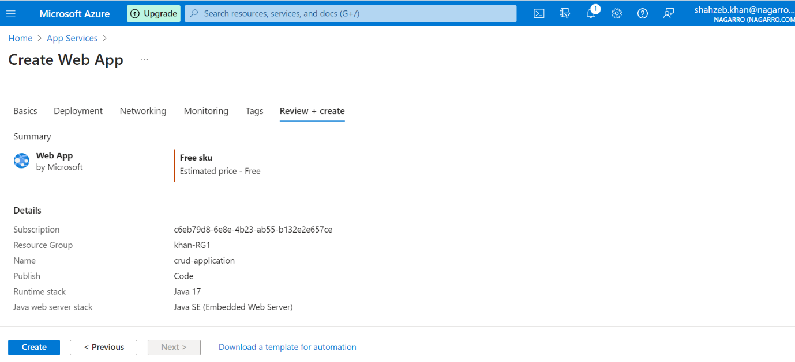

Successfully created web app

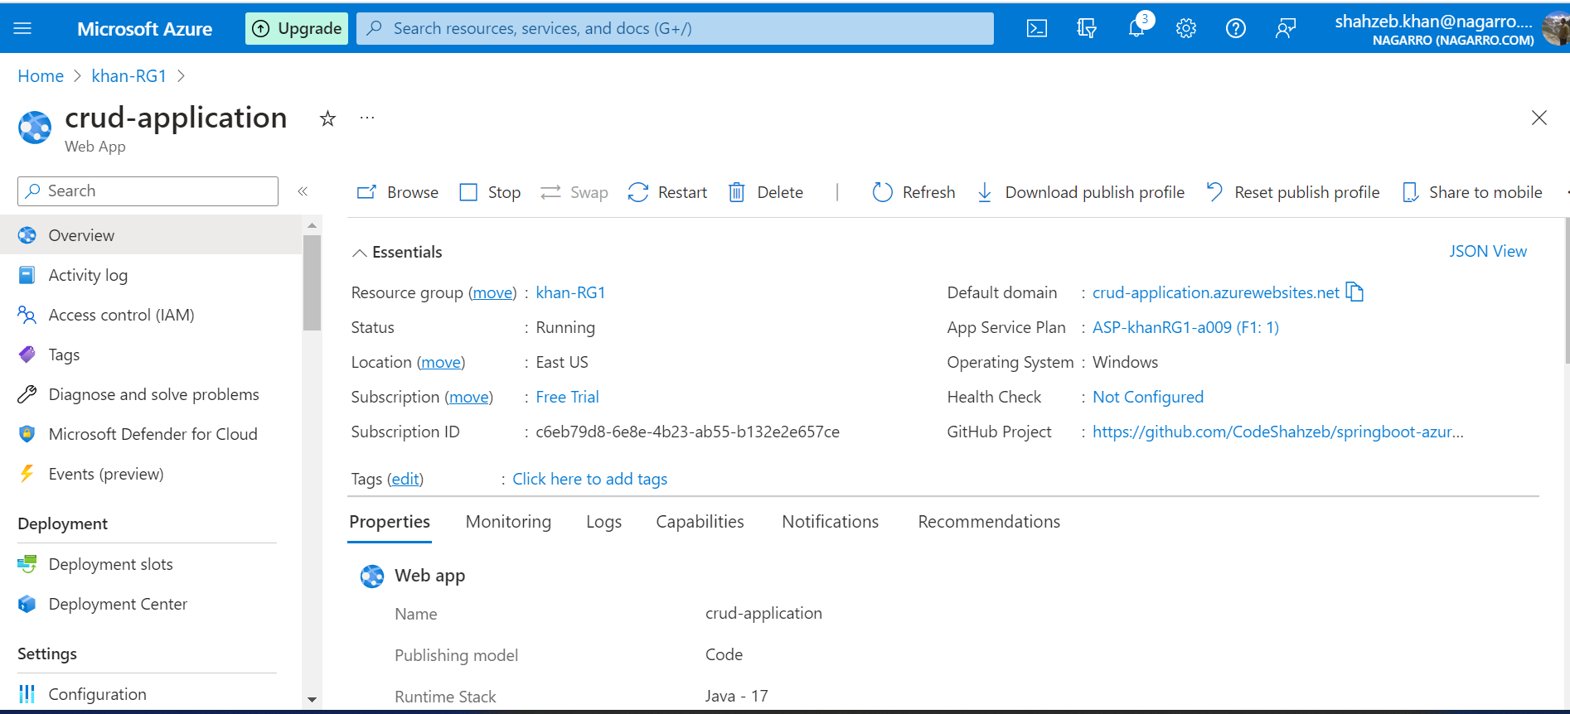

Then copy the URL of Web APP and paste in browser and see the output of deploy application.

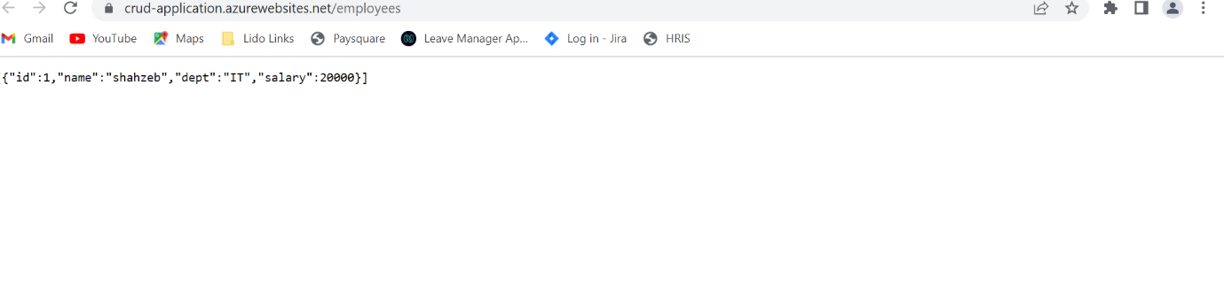

4. Create the AKS cluster (2 nodes, smallest size VM) and deploy any two services on it. Services should be accessible from the internet.

Create an Azure Kubernetes service.

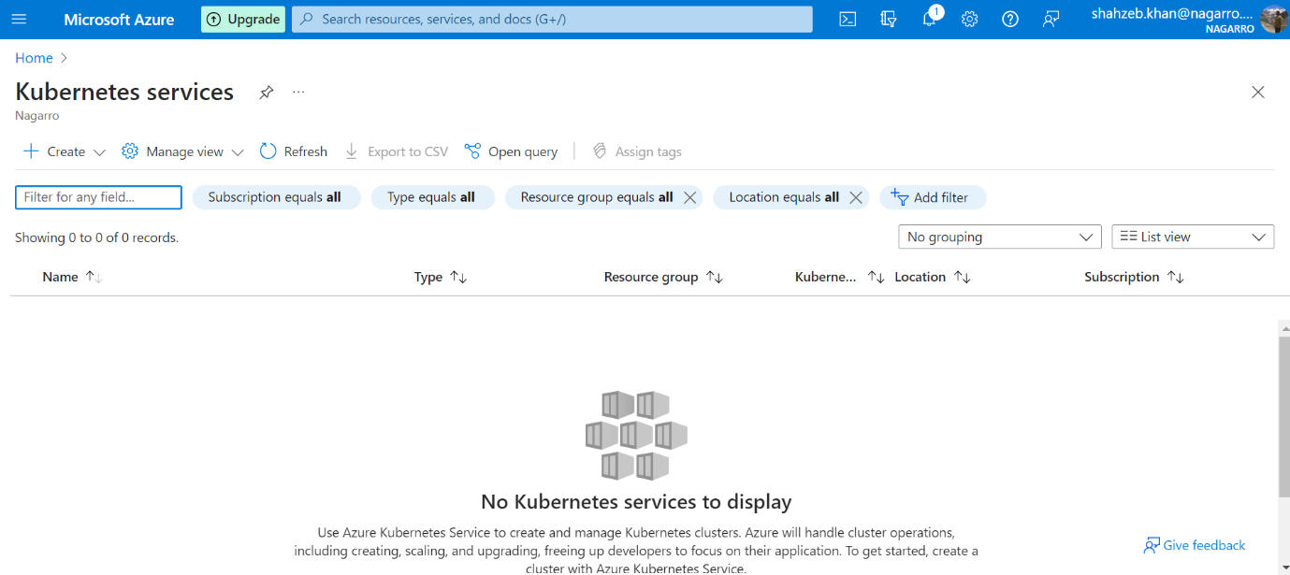

Successfully create AKS name myaks

Then open azure bash and Configure kubectl to connect to your Kubernetes cluster using az aks get-credentials --resource-group khan-RG1 --name myaks

Then apply manifest.yml apply

Deployment and service successfully created. The service is running on that external IP address in myaks Cluster.

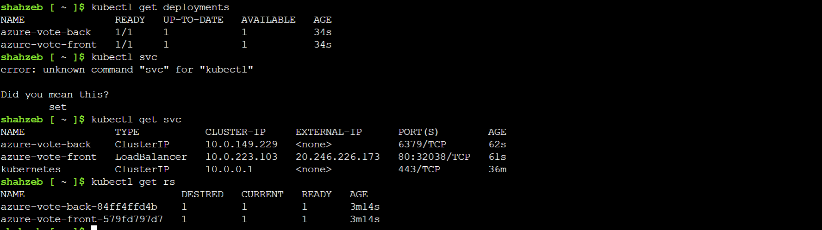

l

Then copy the external IP and paste it in the browser and you can see the application.

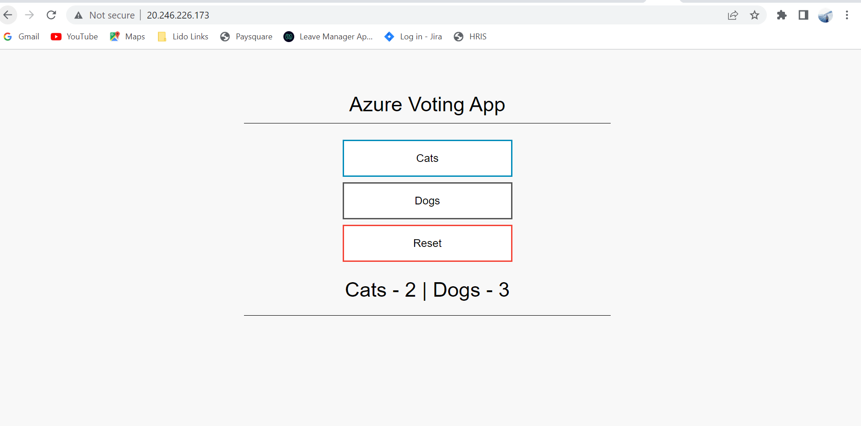

5 Azure Function

Creating storage accounts name shahzebkhanstorage

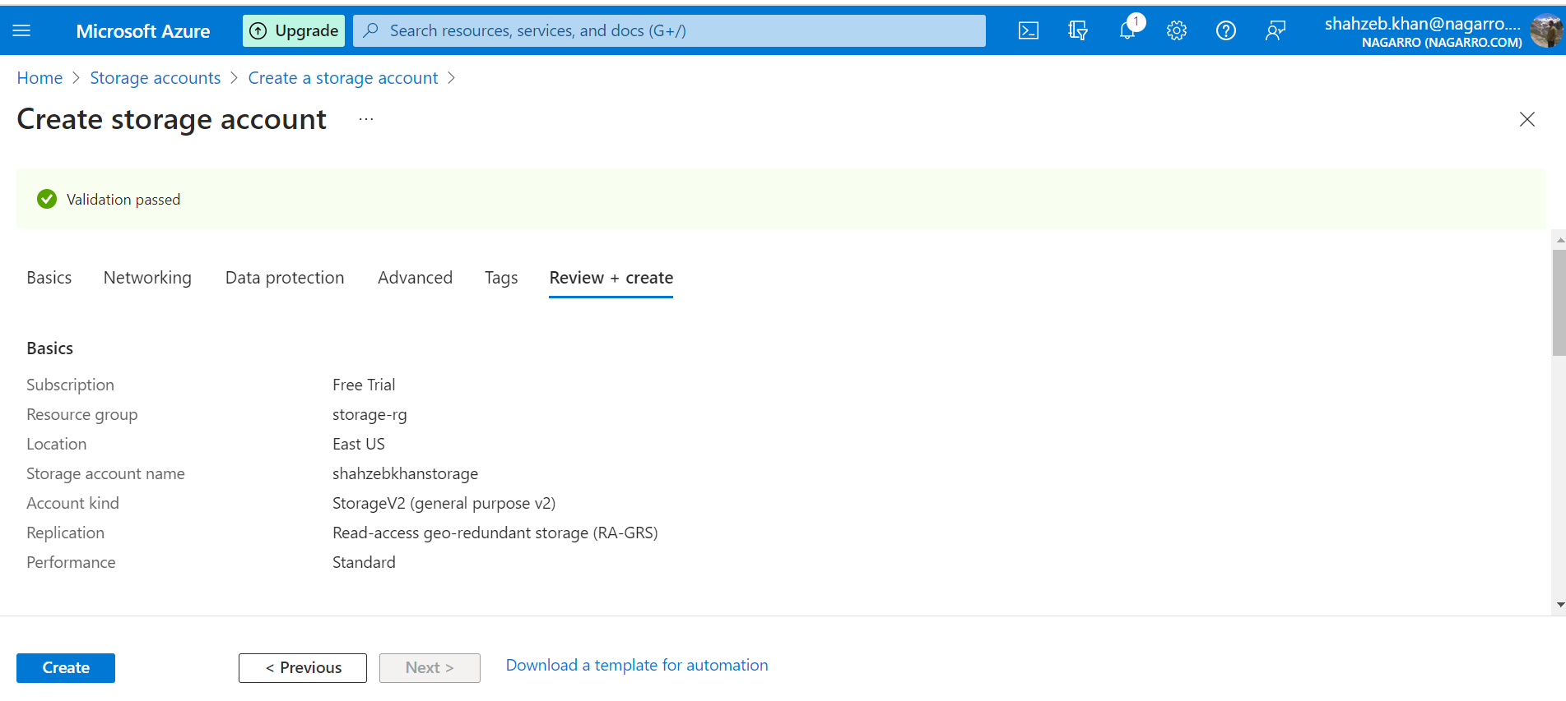

Then Start setting the Function APP.

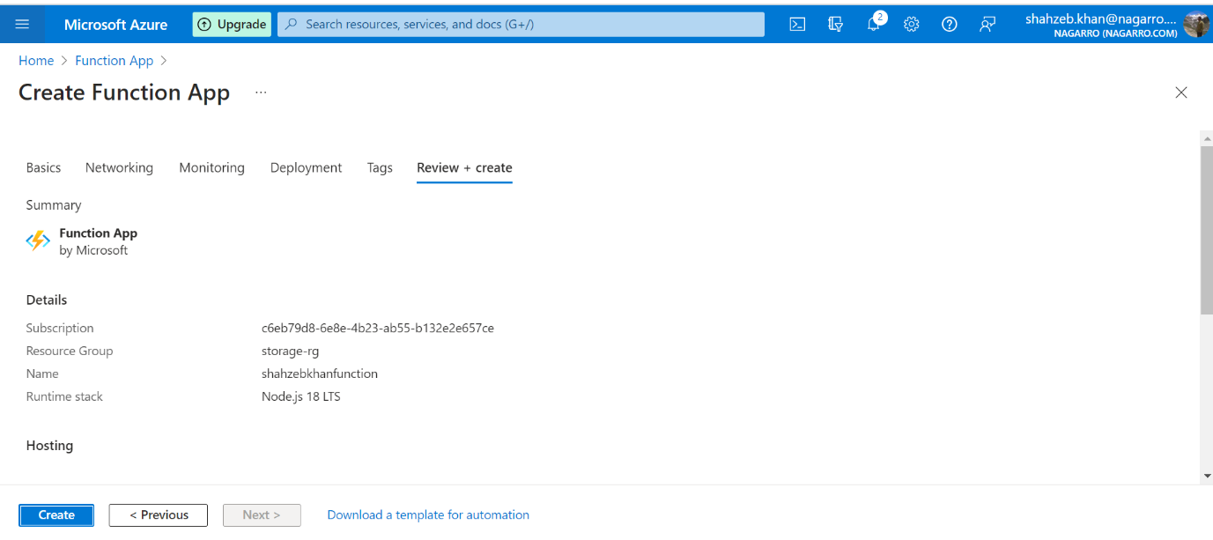

Function APP setup done successfully.

Then create Function name BlogTrigger1.

Creating container in storage so that path matches with it.

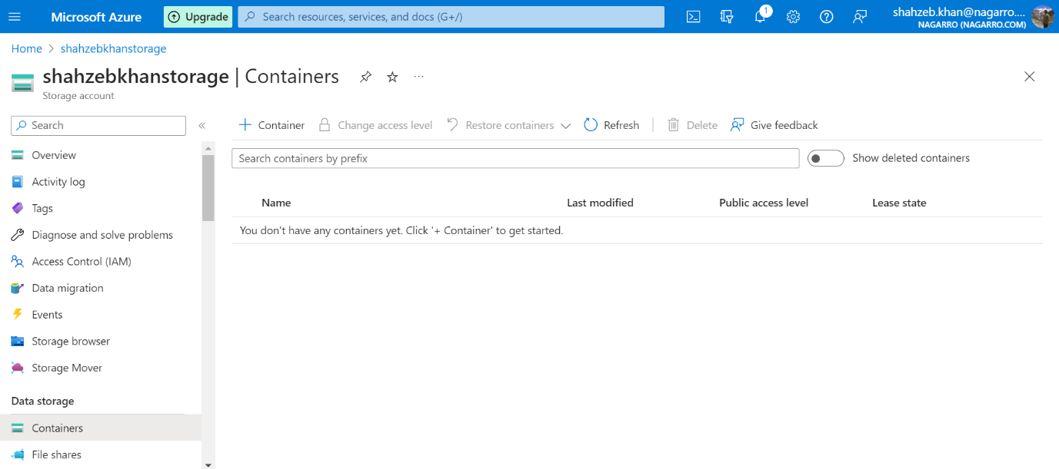

Container created successfully.

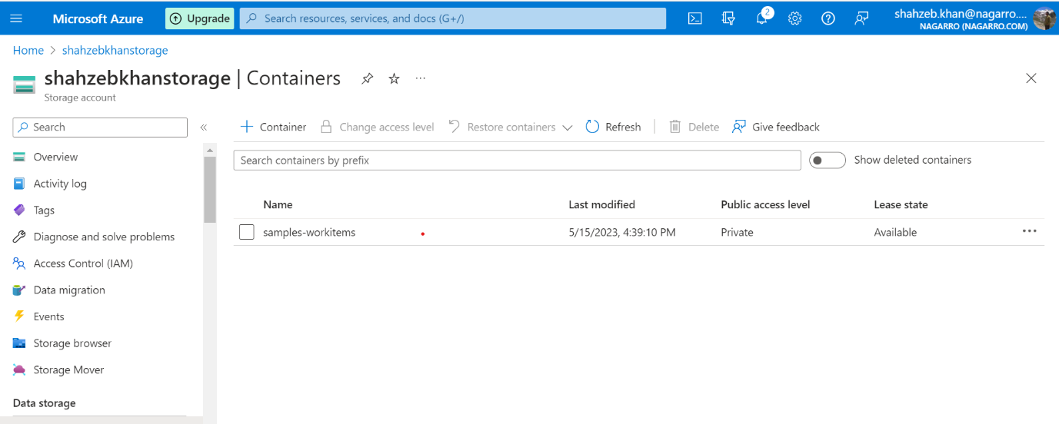

Then Uploaded file into container.

Let’s test the function and press the run button whether it is printing the file name or not.

